**10 SCIENCE 2014**

### EARTH AND SPACE SCIENCE TEST ONE

Name: ____________________ Teacher: ___________________ Mark: /48

**Percentage: %**

**SECTION A: MULTIPLE CHOICE (15 marks)**

**Please answer on the multiple choice answer grid below.**

1. A B C D 10. A B C D

2. A B C D 11. A B C D

3. A B C D 12. A B C D

4. A B C D 13. A B C D

5. A B C D 14. A B C D

6. A B C D 15. A B C D

7. A B C D

8. A B C D

9. A B C D

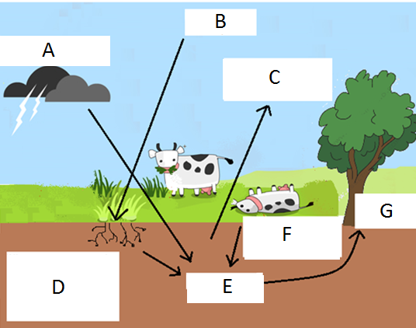Questions 1-5 are based on the diagram of the nitrogen cycle on the right.

1. Label ‘A’ shows lightning:

(a) converting nitrates to nitrogen gas.

(b) converting nitrogen gas to nitrates.

(c) denitrifying nitrates to nitrogen gas.

(d) warming the air.

2. Label ‘B’ refers to:

(a) nitrogen gas in the soil.

(b) nitrates in the soil.

(c) nitrates in the atmosphere.

(d) nitrogen gas in the atmosphere.

3. Label ‘F’ shows:

(a) decomposers rotting a dead animal to return nitrates to the soil.

(b) nitrogen fixing bacteria converting nitrogen gas back to nitrates.

(c) nitrogen fixing bacteria converting nitrates in soil back to nitrogen gas.

(d) denitrifying bacteria converting nitrates in soil back to nitrogen gas.

4. The process where plants convert atmospheric carbon dioxide and water from the soil into in simple sugars (glucose) is called:

(a) respiration.

(b) transpiration.

(c) photosynthesis.

(d) transduction.

5. Legume plants have:

(a) root nodules for converting nitrogen gas to nitrates.

(b) root hairs that convert atmospheric carbon and water from the soil into in simple sugars.

(c) denitrifying bacteria in root nodules converting nitrates to nitrogen gas.

(d) nitrogen fixing bacteria in root nodules converting nitrates to nitrogen gas.

6. Select the correct definition for ‘gyres’:

(a) large frozen Ice masses.

(b) unequal heating of the surface of the Erath.

(c) circular patterns (or currents) made by ocean currents in major ocean basins.

(d) warm air currents.

7. The warming of the ocean is caused by:

(a) the geothermal heat from below the seabed.

(b) the respiration of algae in the upper layers of the oceans.

(c) the Sun.

(d) all of the above.

8. Many fungi and bacteria in the soils are examples of:

(a) decomposers.

(b) photosynthesisers.

(c) interglacials.

(d) nitrogen fixers.

9. Changes in weather patterns over a long period of time is known as:

(a) climate change.

(b) greenhouse effect.

(c) climate.

(d) global warming.

10. Select the **incorrect** statement below.

(a) Three main greenhouse gases are carbon dioxide, water vapour and methane.

(b) Three main greenhouse gases are carbon dioxide, nitrous oxide and nitrogen.

(c) Three main greenhouse gases are methane, nitrous oxide and water vapour.

(d) Three main greenhouse gases are carbon dioxide, methane and ozone.

11. Evaporation in the water cycle is due to:

(a) global warming only

(b) carbon sinks.

(c) the Sun.

(d) the nitrogen cycle.

12. Select the correct statement.

(a) The energy that comes from the Sun is short-wave radiation.

(b) The energy that comes from the Sun is long-wave radiation.

(c) The energy that comes from the Sun is medium-wave radiation.

(d) The energy that comes from the sun is micro-wave radiation.

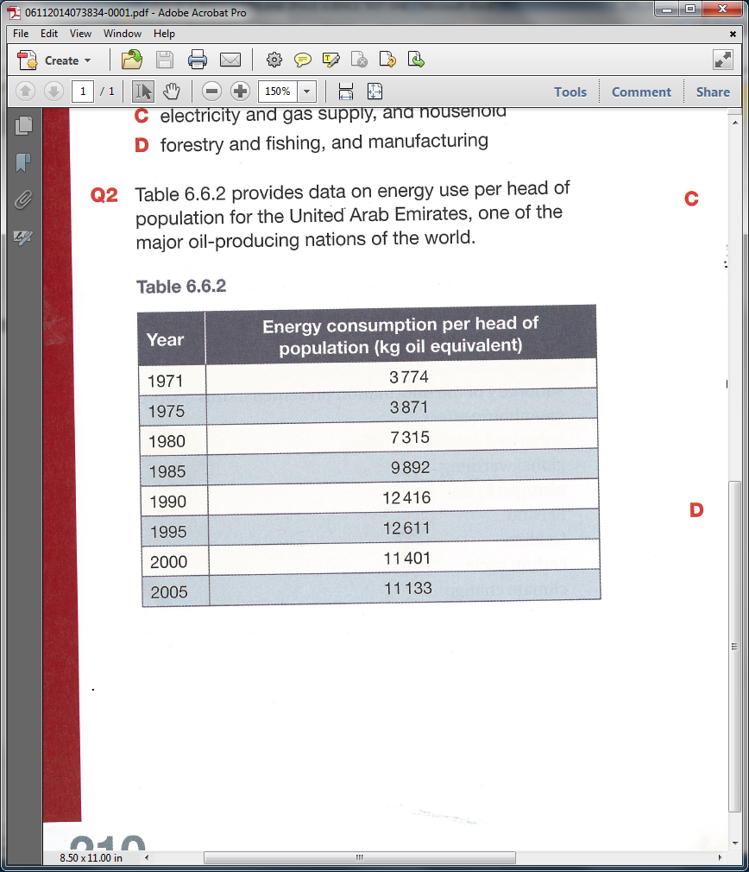13. The table on the right shows data on energy use per head of population for the United Arab Emirates, one of the major oil-producing nations of the world.

Which graph best represents the data in the table?

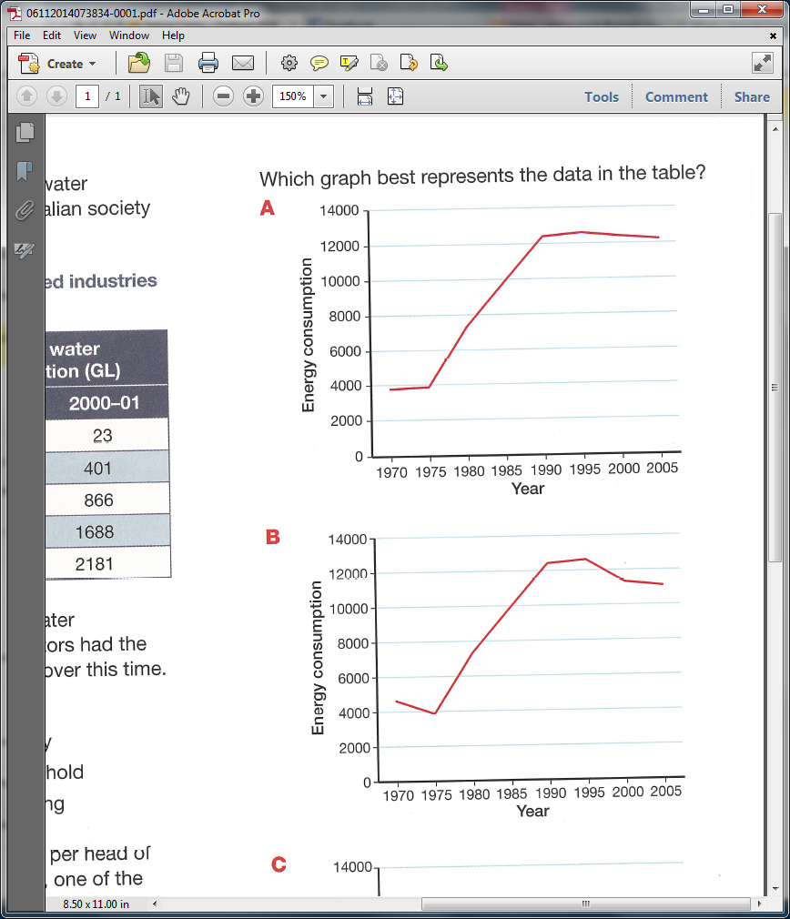

(a) (b)

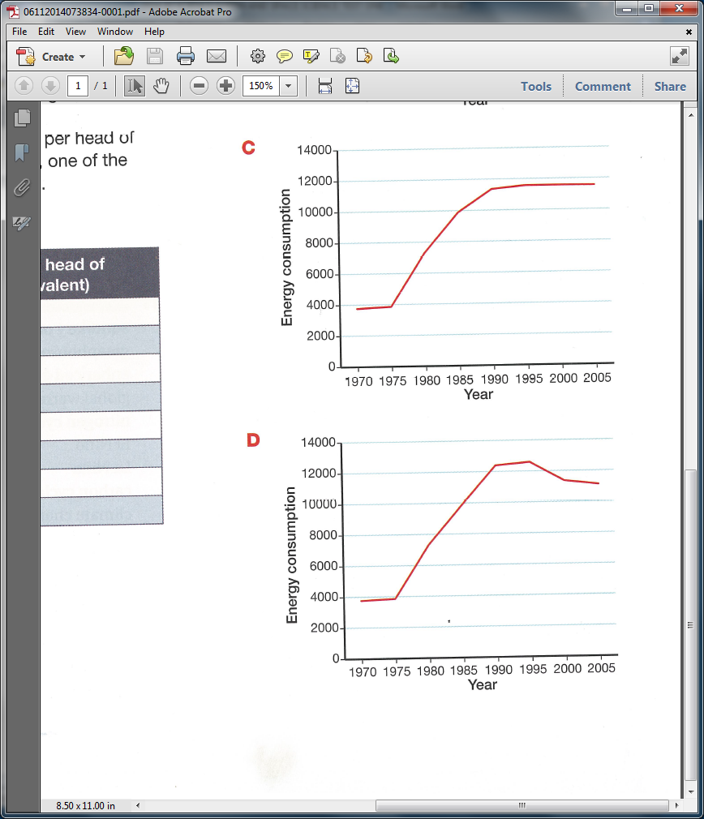

(c) (d)

14. The process where all living cells burn glucose to release energy, water vapour and carbon dioxide is called:

(a) carbon sinks

(b) respiration.

(c) transpiration.

(d) photosynthesis.

15. Precipitation is:

(a) the soaking of rain water through the soil into the ground water..

(b) the coral releasing protists that live within their cells.

(c) condensed water from clouds falling as rain or snow.

(d) the coral absorbing protists into their cells.

**SECTION B: SHORT ANSWER (33 marks)**

**1.** Explain the difference between weather and climate. (2 marks)

_____________________________________________________________________________________

_____________________________________________________________________________________

_____________________________________________________________________________________

**2.** List two examples of leguminous plants. (1 mark)

__________________________ ____________________________

**3.** Label the different spheres in the diagram below. (2 marks)

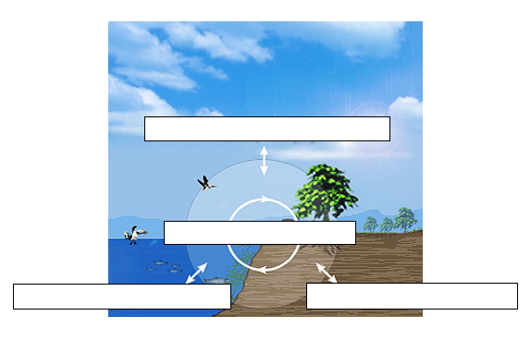

**4.** Explain why do those areas of the Earth’s surface covered in ice do not warm as fast as those areas covered by dark forests? (4 marks)

_____________________________________________________________________________________

_____________________________________________________________________________________

_____________________________________________________________________________________

_____________________________________________________________________________________

_____________________________________________________________________________________

_____________________________________________________________________________________

_____________________________________________________________________________________

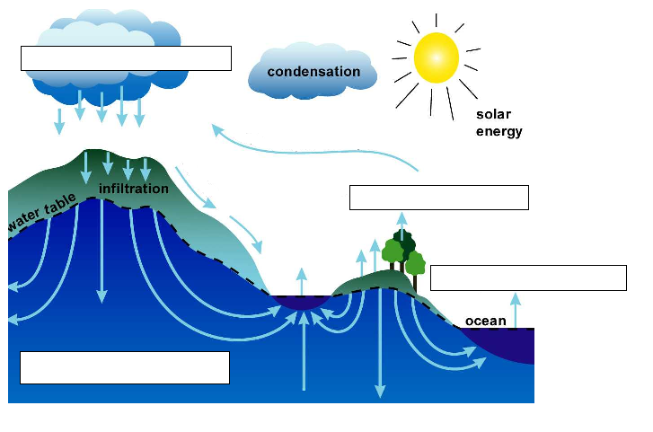**5.** Label the diagram of the water cycle shown below. (2 marks)

**6.** Name an example of a greenhouse gas. List **4** sources of this greenhouse gas. (5 marks)

_________________________________

____________________________________________________________________________________

____________________________________________________________________________________

____________________________________________________________________________________

**7.** One suggested way of reducing the impact of carbon emissions is to plant more trees. (2 marks)

Explain why this would be a useful strategy.

_____________________________________________________________________________________

_____________________________________________________________________________________

_____________________________________________________________________________________

_____________________________________________________________________________________

_____________________________________________________________________________________

**8.** Match the terms to their definitions by writing the number of the correct definition in the box.(5 marks)

|  |  |  |  |
| --- | --- | --- | --- |
|  | **TERM** |  | **DEFINITION** |
|  | Enhanced greenhouse effect | 1. | All the liquid water on the Earth’s surface. |
|  | Biosphere | 2. | The warming of the Earth caused by greenhouse gases. |
|  | Hydrosphere | 3. | Land masses on Earth. |
|  | Greenhouse effect | 4. | The preserved remains of once-living organisms. |
|  | Atmosphere | 5. | The layers of gases surrounding the planet. |
|  | Fossils | 6. | A time when the average world temperature is increasing. |
|  | Global warming | 7. | Increase in the natural greenhouse effect caused by human activity. |
|  | Fossil fuels | 8. | All living things on Earth. |
|  | Lithosphere | 9. | The variety of ecosystems in the biosphere, the variety of species within those ecosystems and the genetic variation within those species. |
|  | Biodiversity | 10. | Fuels that contain the carbon of plants and animals that died and were preserved millions of years ago. |

**9.** It is predicted that the Kakadu National Park in the Northern Territory will be impacted by rising sea levels and increased storm activities as results of climate change.

Describe one way that organisms in Kakadu National Park will be impacted. (2 marks)

_____________________________________________________________________________________

_____________________________________________________________________________________

_____________________________________________________________________________________

_____________________________________________________________________________________

**10.** Circle either true or false for the following statements. (3 marks)

The climate of Australia varies from day to day. True False

Nitrogen gas in the atmosphere is absorbed by plants through their leaves. True False

The largest amount of water vapour comes from oceans. True False

The Earth’s surface is the coldest that it has ever been. True False

Nitrogen gas is the most common gas in the Earth’s atmosphere. True False

95% of the carbon dioxide would be produced on Earth whether humans True False

were present or not.

**11.** The table below shows the carbon dioxide output per head of population in Australia from 1965 to 2005.

Draw a graph using the information from the table below. (5 marks)

|  |  |
| --- | --- |
| **Year** | **CO2 output**  **(metric tonnes per head of population)** |
| 1965 | 10.6 |
| 1975 | 11.9 |
| 1985 | 15.2 |
| 1995 | 17.1 |
| 2005 | 18.1 |

[](http://www.google.com.au/url?sa=i&rct=j&q=graph+paper&source=images&cd=&cad=rja&uact=8&docid=bnDyK-WDEHhooM&tbnid=OH_xw5ZTcFEuvM:&ved=0CAUQjRw&url=http://virtualmathtutor.blogspot.com/2010/11/how-to-draw-circle-without-compass.html&ei=RKw4U5fxF8fClQWCrIGoCQ&psig=AFQjCNHahbsWAgdANQM5RZCXw4z48cLLBw&ust=1396309252654415)